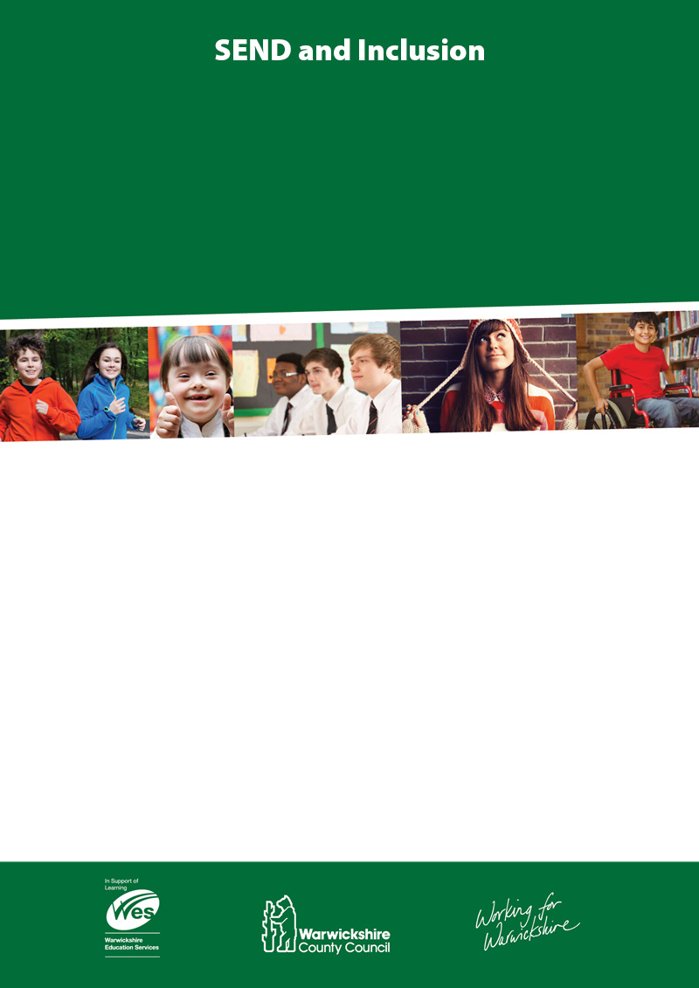

**What is Talking Partners?**

Talking Partners is a structured oral language programme which raises levels of achievement by improving learner’s listening and speaking skills. It is an evidence based targeted, time limited (10 weeks) intervention that can be used with learners in KS3 and KS4.

**Who is Talking Partners for?**

Talking Partners is for pupils who are:

* Lacking in skills and confidence as speakers and listeners
* EAL learners
* SEN
* SEMH

**Who delivers Talking Partners?**

Experienced TAs and HLTAs after receiving 2-days of intensive training to become trained partners. A SENCO (also expected to attend the training), is appointed as the school coordinator and monitors the intervention. Partners receive a training pack, which contains full descriptions of activities, frameworks for teaching and assessment materials to support delivery and measure impact.

**TALKING PARTNERS@Secondary**

1.5 day training course

(Teacher and TA required to run programmes successfully)

**Total Cost: £125 per person this includes:**

* 1.5 days training delivered by accredited Talking Partners (TP) trainers
* TP resource pack, frameworks, assessment toolkit and training manual ( the value of £75 already included in the total)

Develop capacity to meet the needs of Pupils on the Autism Spectrum by signing up for…

**Autism Education Trust Training**

We offer a nationally acclaimed, face to face, personalised, multi-tier training programme, supported and quality assured by the Department for Education