How to register and sign into Employee Self Service (ESS), the new home of your Payslip
1 – Enter this link onto your computer/laptop/smart phone
https://apps.warwickshire.gov.uk/SchoolsIDP/users/sign_up
2 - Then complete the following details (you will only need to complete this part once to register). The email address you enter is the one you provided to your school and if they need to check it will be the one entered in to your “work email” on the system
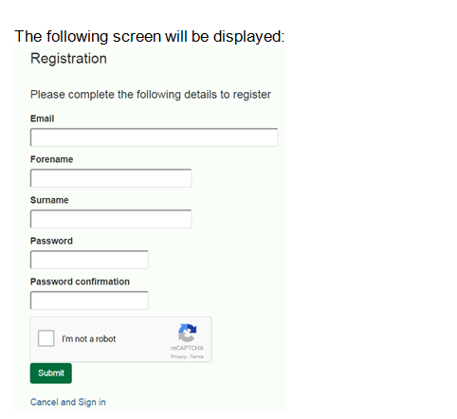
3 - When creating your password please make sure it is over 8 characters and includes at least 1 upper case (capital) and 1 number
4 – You will now receive an email, if you click on the link it will confirm activation of your account
You are ready to access Employee Self Service in Your HR

Copy this link into your browser and save/bookmark for future use - https://ce0242li.webitrent.com/ce0242li_ess/ess/index.html#/login -

The screen below will appear:

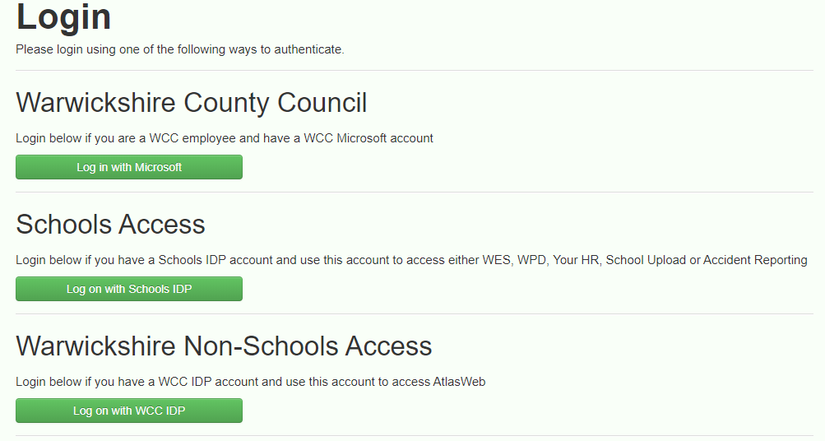

Under the Schools Access section, click on the ‘Log on with Schools IDP’ option. You will be presented with the following screen where you enter the email address and password that you registered with;

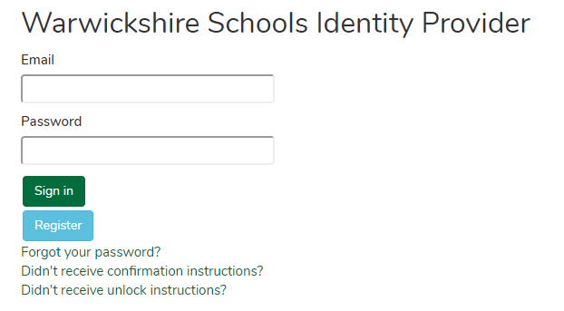

Welcome - You are now in Employee Self Service
Now you have access, you are required to check and ensure that your personal details are correct and up-to-date.
You are also required to set your eForm preferences so that your payslips and P60 can be emailed to you, using an email address of your choice. At the very latest, this needs to be done before you leave school employment to ensure you receive your final payslip
There are a number of Guides on the homepage of Your HR
- Bank details
- Personal details
- Eform preferences
FREQUENTLY ASKED QUESTIONS
Q. I can’t remember which email address is used for my Schools IdP registration. How can I find this out?
A. Contact your School Office and they will confirm this. It will always be the email that is held in Your HR in the field called ‘Work email’. Please note this could actually be a personal email if you do not have a work email.

Q. I’ve forgotten my password for Schools IdP. How do I reset it?
A. From the Schools IdP Login screen, click on the ‘Forgot your password?’ and follow the online instructions.

Q. I need to amend my bank details. How can I do this?
A. If you do NOT have a Your role for Employee Self-Service (ESS) then please provide your new bank details to your School Office who will update the details on your behalf.

If you DO have a Your HR role for (ESS), you must make the changes in the system. Follow the step by step guidance which can be accessed from the homepage under ‘User Guides’ > ‘Update my bank details’.

Q. How do I access my payslips / P60s?
A. If you do NOT have a Your role for Employee Self-Service (ESS) then your School Office will advise whether you will receive paper payslips/P60s or whether these will be emailed to you.

If you DO have a Your HR role for (ESS), you can view and download these via the system. Follow the step by step guidance which can be accessed from the homepage under ‘User Guides’ > ‘View and download my payslips and P60s’. You must also ensure that you set up your e-Form preferences to receive your payslip by email each month in addition to being able to view it in ESS. Please refer to ‘User Guides’ > ‘Set my e-Form preferences’.

Q. What is the process for changing my email address (e.g. due to a name of my marital status)?
A. You are required to notify your School Office if your name changes and ensure supporting documentary evidence is provided e.g. a marriage certificate.

Your school office will amend your ‘Personal email’ on Your HR for you. They will then notify WES HR of the change so that your ‘User email’ and ‘Work email’ addresses can be updated. You will be notified once this has been actioned and will be provided with the email address you need to use to amend your Schools IdP details. To do this:

· Log in to Schools IdP and click on the ‘Edit your details’ link
· In the ‘Email address’ field, you must enter the email provided by WES HR
· Amend your name as required
· Click on ‘Update’ to save the changes
· You will receive an email confirmation. Click on the link within this email to activate the changes to your account.

The changes will take place overnight so you will not be able to access Your HR until the following day.

Note: If you also need to change the email addresses for receiving your e-mail payslip/P60, please remember to do this by updating the e-Form preferences screen in ESS.

Q. I am due to leave my employment in the near future; is there anything I need to do if I have Employee Self-Service (ESS) access?
A. Yes, if you haven’t already done so please ensure you download and save your previous payslips and P60s and set your e-Form preferences so that your final payslip can be emailed to you. There is a charge for requesting copies of payslips if you do not need this. Your access to ESS will be automatically end dated from your leaving date so you will not be able to access the system after this date.

Q. I left part way through the month and my access to Employee Self-Service (ESS) no longer works so I cannot access my final payslip
A. Your access is automatically end dated using your leaving date. If you did not set your e-Form preferences before you left, you will have to request your payslip to be sent to your home address by using the contact details at the end of this document.

Help with Your HR
For WES HR
Please email using the information below if you require any technical support with the system.
Email: weshrandpayroll@warwickshire.gov.uk

For Payroll Queries
For all queries relating to your record or pay, please contact your School Office in the first instance

